Course Outcome Assessment – 2
ITA0502 – COMPUTER VISION
Submitted by
M Yasodha Krishna (192472100)

Under the Supervision of
Dr. R. C. Jeni Gracia

ANNEXURE A – SCENARIO BASED ASSESSMENT
Scenario 1: Manufacturing Quality Inspection
(a) Interpret the scenario and identify the type of noise present.
In an automated manufacturing industry, quality inspection systems use digital cameras to capture images of metal components for detecting defects such as cracks, scratches, dents, and surface irregularities. During image acquisition, electrical interference introduces repetitive horizontal stripe patterns across the captured images. These unwanted stripes reduce the quality of the image and make defect detection difficult.
The type of image degradation present in this scenario is Periodic Noise. Periodic noise appears as regularly repeating horizontal or vertical patterns and is mainly caused by electrical interference or electromagnetic disturbances during image acquisition or transmission.
Figure 1: Metal Component Image Affected by Periodic Noise
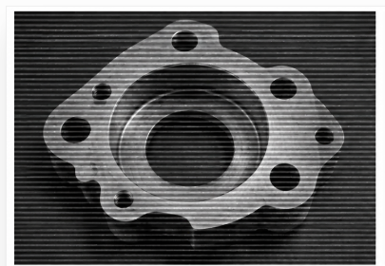
Figure 1. Original metal component image showing repetitive horizontal stripe patterns caused by electrical interference (Periodic Noise).
(b) Explain how this degradation affects inspection accuracy.

The periodic noise reduces the visual quality of the image and hides important surface defects. Small cracks, scratches, and dents become difficult to identify because the horizontal stripes overlap with the actual object details. This may cause the automated inspection system to incorrectly classify defective products as good products or reject good products as defective. Therefore, the reliability and accuracy of the quality inspection system decrease significantly.
(c) Recommend an appropriate enhancement technique to remove the interference.
The most suitable enhancement technique is Frequency Domain Filtering using a Notch Reject Filter.
The captured image is first converted into the frequency domain using the Fourier Transform (FT). In the frequency domain, periodic noise appears as distinct bright frequency peaks. A Notch Reject Filter removes these unwanted frequencies while preserving the important image information. Finally, the image is converted back to the spatial domain using the Inverse Fourier Transform (IFT).
Figure 2: Image After Applying Notch Reject Filter
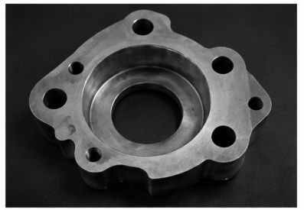
Figure 2. Enhanced image after applying a Notch Reject Filter. The periodic horizontal stripes are removed while preserving the important details of the metal component.
(d) Justify why your selected approach is more suitable than spatial-domain methods.
The Notch Reject Filter is more effective because periodic noise can be clearly identified in the frequency domain. It removes only the unwanted periodic frequency components without affecting the useful image information.
Spatial-domain filters such as Mean Filter, Gaussian Filter, and Median Filter process the entire image uniformly. Although they reduce some types of noise, they cannot effectively remove periodic stripe patterns and may blur important edges and fine details. Therefore, the Frequency Domain Notch Reject Filter provides better image quality and improves defect detection accuracy.
(e) Explain your answer in a logical sequence.

The quality inspection system captures images of metal components. Electrical interference introduces repetitive horizontal stripe patterns known as periodic noise. This degradation reduces image quality and makes defect detection unreliable. The image is transformed into the frequency domain using the Fourier Transform. A Notch Reject Filter removes the unwanted periodic frequency components. Finally, the enhanced image is reconstructed using the Inverse Fourier Transform. The resulting image has improved clarity, allowing the inspection system to detect defects more accurately.

Scenario 2: Autonomous Vehicle Navigation
(a) Interpret the scenario and explain the challenge involved.
Autonomous vehicles use cameras to capture road images for detecting lane markings, road boundaries, traffic signs, pedestrians, and other vehicles. During heavy rainfall, rain droplets introduce noise into the captured images, reducing their clarity. Although noise is present, lane markings and road edges must remain sharp because they are essential for safe vehicle navigation.
The main challenge is to remove the noise while preserving important image edges so that the autonomous vehicle can correctly identify lanes and surrounding objects.
Figure 3: Road Image Captured During Heavy Rain
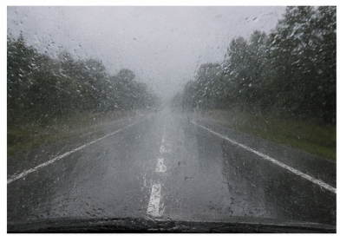
Figure 3. Road image captured during heavy rain showing noise while lane markings remain partially visible.
(b) Identify the importance of preserving edges while removing noise.
Edges represent the boundaries of important objects such as lane markings, road boundaries, traffic signs, pedestrians, and vehicles. Preserving these edges is essential because they provide the information required for accurate object detection and lane recognition.
If the edges become blurred during noise removal, the autonomous vehicle may incorrectly detect lanes or fail to recognize obstacles, increasing the possibility of accidents. Therefore, edge preservation is a critical requirement in autonomous vehicle navigation.
(c) Recommend a suitable filtering technique.

The most appropriate filtering technique is the Bilateral Filter.
The Bilateral Filter removes noise while preserving sharp edges by considering both the spatial distance between pixels and the difference in pixel intensity values.
Figure 4: Image After Applying Bilateral Filter
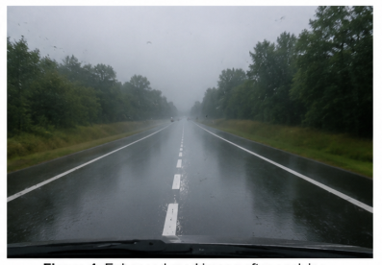
Figure 4. Enhanced road image after applying a Bilateral Filter. Noise is reduced while lane markings and road edges remain sharp.
(d) Justify why your selected filter preserves important image details.
The Bilateral Filter performs edge-preserving smoothing by averaging only those neighboring pixels that are both spatially close and similar in intensity. This prevents smoothing across object boundaries, thereby preserving important edges.
Unlike Mean or Gaussian filters, which smooth all neighboring pixels and blur image edges, the Bilateral Filter maintains the sharpness of lane markings, road boundaries, and other important features while effectively reducing noise.
(e) Present your explanation clearly and systematically.
The autonomous vehicle captures road images during heavy rainfall. Rain introduces unwanted noise that reduces image quality. Since lane markings and road edges are important for safe driving, edge preservation becomes essential. The Bilateral Filter is applied to remove the rain-induced noise while preserving the important edges. After filtering, the image becomes clearer, lane markings remain visible, and the vehicle can accurately detect lanes and surrounding objects. This improves navigation accuracy and ensures safer autonomous driving.
Conclusion
Image enhancement techniques play an important role in improving the performance of computer vision systems. In manufacturing quality inspection, periodic noise caused by electrical interference is effectively removed using a Frequency Domain Notch Reject Filter, which preserves important image details while eliminating repetitive stripe patterns. In autonomous vehicle navigation, the Bilateral Filter is the preferred choice because it removes noise while maintaining sharp lane markings and road edges. Choosing the appropriate enhancement technique based on the type of image degradation improves image quality, increases detection accuracy, and enhances the overall reliability of real-world computer vision applications.

